KUBERNETES (K8S)
KUBERNETES:
Kubernetes is a container orchestration system that manages, scales, and deploys containerized applications. It's also known as "k8s".
Container orchestration is the automated process of managing the lifecycle of containerized applications, including deployment, scaling, and resource allocation, in a distributed and dynamic environment.
What Kubernetes does
- Manages applications
  - Kubernetes automates tasks like deploying, scaling, and monitoring applications.
- Manages resources
  - Kubernetes tracks resource allocation and manages the shared state of the cluster.
- Scales applications
  - Kubernetes can scale applications up and down to meet changing needs.
- Manages services
  - Kubernetes groups a set of Pod endpoints into a single resource, called a Service.
- Manages access
  - Kubernetes uses role-based access control (RBAC) to regulate access to resources based on user roles.

List the features of Kubernetes.
Some of the features of Kubernetes are:
Automated scheduling: Kubernetes automatically schedules containers to run on the available resources in the cluster.
Self-healing capabilities: Kubernetes automatically replaces failed containers and reschedules them on healthy nodes in the cluster.
Automated rollouts and rollback: Kubernetes is responsible for automating the deployment process, enabling users to roll out new versions of their applications easily and roll them back in case of any issues.
Horizontal scaling and load balancing: Kubernetes automatically scales and distributes traffic across multiple instances of a containerized application.
Configuration management: Kubernetes enables users to define and manage the application configuration settings separately from the application code.
Service discovery & networking: Kubernetes provides a built-in service discovery mechanism to locate and communicate with other services in the cluster.
Security & compliance: Kubernetes provides several security features, including access control to ensure the security of the cluster and compliance with organizational policies.
Kubernetes use cases
- Large-scale app deployment
- High-performance computing
- AI and machine learning
- Microservices management
- Hybrid and multicloud deployments
- Enterprise DevOps

Let's take a look at why Kubernetes is so useful by going back in time.
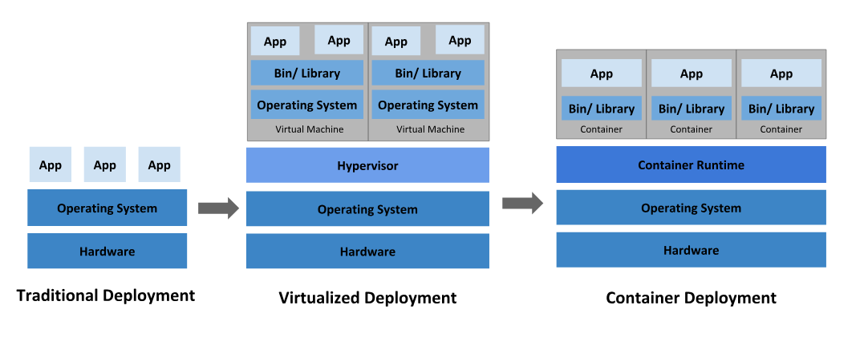
Traditional deployment era:
Early on, organizations ran applications on physical servers. There was no way to define resource boundaries for applications in a physical server, and this caused resource allocation issues. For example, if multiple applications run on a physical server, there can be instances where one application would take up most of the resources, and as a result, the other applications would underperform. A solution for this would be to run each application on a different physical server. But this did not scale as resources were underutilized, and it was expensive for organizations to maintain many physical servers.

Virtualized deployment era:
As a solution, virtualization was introduced. It allows you to run multiple Virtual Machines (VMs) on a single physical server's CPU. Virtualization allows applications to be isolated between VMs and provides a level of security as the information of one application cannot be freely accessed by another application.
Virtualization allows better utilization of resources in a physical server and allows better scalability because an application can be added or updated easily, reduces hardware costs, and much more. With virtualization you can present a set of physical resources as a cluster of disposable virtual machines.
Each VM is a full machine running all the components, including its own operating system, on top of the virtualized hardware.

Container deployment era:
Containers are similar to VMs, but they have relaxed isolation properties to share the Operating System (OS) among the applications. Therefore, containers are considered lightweight. Similar to a VM, a container has its own filesystem, share of CPU, memory, process space, and more. As they are decoupled from the underlying infrastructure, they are portable across clouds and OS distributions.
Containers have become popular because they provide extra benefits, such as:
- Agile application creation and deployment: increased ease and efficiency of container image creation compared to VM image use.
- Continuous development, integration, and deployment: provides for reliable and frequent container image build and deployment with quick and efficient rollbacks (due to image immutability).
- Dev and Ops separation of concerns: create application container images at build/release time rather than deployment time, thereby decoupling applications from infrastructure.
- Observability: not only surfaces OS-level information and metrics, but also application health and other signals.
- Environmental consistency across development, testing, and production: runs the same on a laptop as it does in the cloud.
- Cloud and OS distribution portability: runs on Ubuntu, RHEL, CoreOS, on-premises, on major public clouds, and anywhere else.
- Application-centric management: raises the level of abstraction from running an OS on virtual hardware to running an application on an OS using logical resources.
- Loosely coupled, distributed, elastic, liberated micro-services: applications are broken into smaller, independent pieces and can be deployed and managed dynamically – not a monolithic stack running on one big single-purpose machine.
- Resource isolation: predictable application performance.
- Resource utilization: high efficiency and density.

How Kubernetes works
Kubernetes manages containerized applications by organizing them into a cluster of nodes, with a control plane managing the cluster state and worker nodes hosting containers in pods, all while using a distributed key-value store (etcd) for configuration and state management. For this go through cluster Architecture
Why use Kubernetes?
Keeping containerized apps up and running can be complex because they often involve many containers deployed across different machines. Kubernetes provides a way to schedule and deploy those containers—plus scale them to your desired state and manage their lifecycles. Use Kubernetes to implement your container-based applications in a portable, scalable, and extensible way.

Pod:

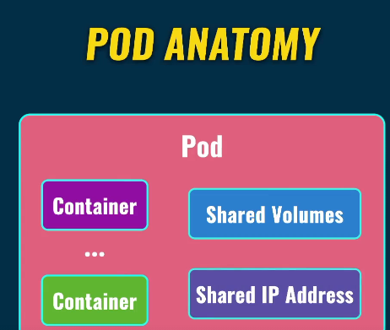

What are Pods?
Pods are Kubernetes Objects that are the basic unit for running our containers inside our Kubernetes cluster. In fact, Pods are the smallest object of the Kubernetes Model.
Pods can contain a single or multiple containers as a group, that share the same resources within that Pod (storage, network resources, namespaces). Pods typically have a 1–1 mapping with containers, but in more advanced situations, we may run multiple containers in a Pod.
Pods are epheremeral resources, meaning that Pods can be terminated at any point and then restarted on another node within our Kubernetes cluster. They live and die, but Pods will never come back to life.
How can we create Pods in Kubernetes?
We can define Pods in Kubernetes using YAML files. Using these YAML files, we can create objects that interact with the Kubernetes API (Pods, Namespace, Deployments etc.). Under the hood, kubectl converts the information that we have defined in our YAML file to JSON, that makes the request to the Kubernetes API.
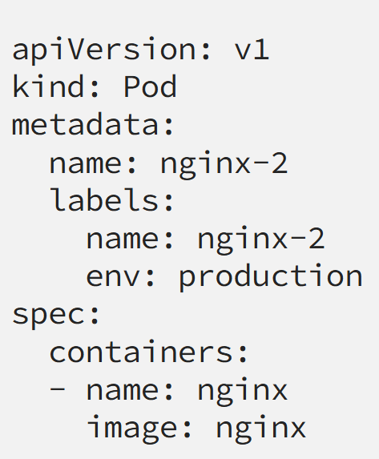

What are the benefits of a pod?
In Kubernetes, pods facilitate efficient container management, offering simplified resource sharing, communication, and networking capabilities, as well as enabling features like scaling and self-healing.
Here's a breakdown of the benefits:
- Resource Management & Sharing:
Pods allow containers to share the same resources, network namespace, and storage volumes, making them ideal for applications with inter-dependent components.
- Simplified Communication:
Containers within the same pod have easy communication through localhost, while the pod itself has a unique IP address that other pods and services can use.
- Scalability and Resilience:
Kubernetes pods support dynamic scaling, with autoscaling features automatically adjusting the number of pod replicas based on demand, ensuring application availability and performance.
- Fault Tolerance and Self-Healing:
Kubernetes can automatically detect and replace failed pods with new ones, ensuring continuous operation even if individual pods fail.
- Efficient Operations:
Pods streamline application deployment and updates, allowing for faster iteration and reduced downtime through features like rolling deployments.
- Configuration Management:
Kubernetes allows for managing configuration data and sensitive information efficiently through ConfigMaps which helps to pass these configuration data to the pods.
- Resource Optimization:
By setting resource demands and limitations, you can control the CPU and memory utilization of pods, optimizing resource allocation.
- Security:
Kubernetes Pod Security Standards help in securing Kubernetes clusters in a simpler and more efficient manne
How do pods communicate with each other?
When a pod is created it is assigned its own unique IP address. If there are multiple containers within the pod, they can communicate between each other simply by using localhost. Communications outside of the pod is achieved by exposing a port. Communications between pods in a cluster takes advantage of the fact that Kubernetes assigns a cluster-private IP address to every pid in a cluster, eliminating the need to either explicitly create links between pods or to map container ports to host ports. In this way, every pod in a cluster can ‘see’ each other without the need for NAT.

Cluster Architecture:
A Kubernetes cluster consists of a control plane plus a set of worker machines, called nodes, that run containerized applications. Every cluster needs at least one worker node in order to run Pods.
Kubernetes cluster benefits
- Allows engineers to orchestrate and monitor containers across multiple environments
- Automates operational tasks, such as deploying applications, scaling, and monitoring
- Provides high availability in case of a node failure
- Allows containers to share operating systems and run anywhere
Kubernetes is an open source platform that facilitates declarative configuration and automation

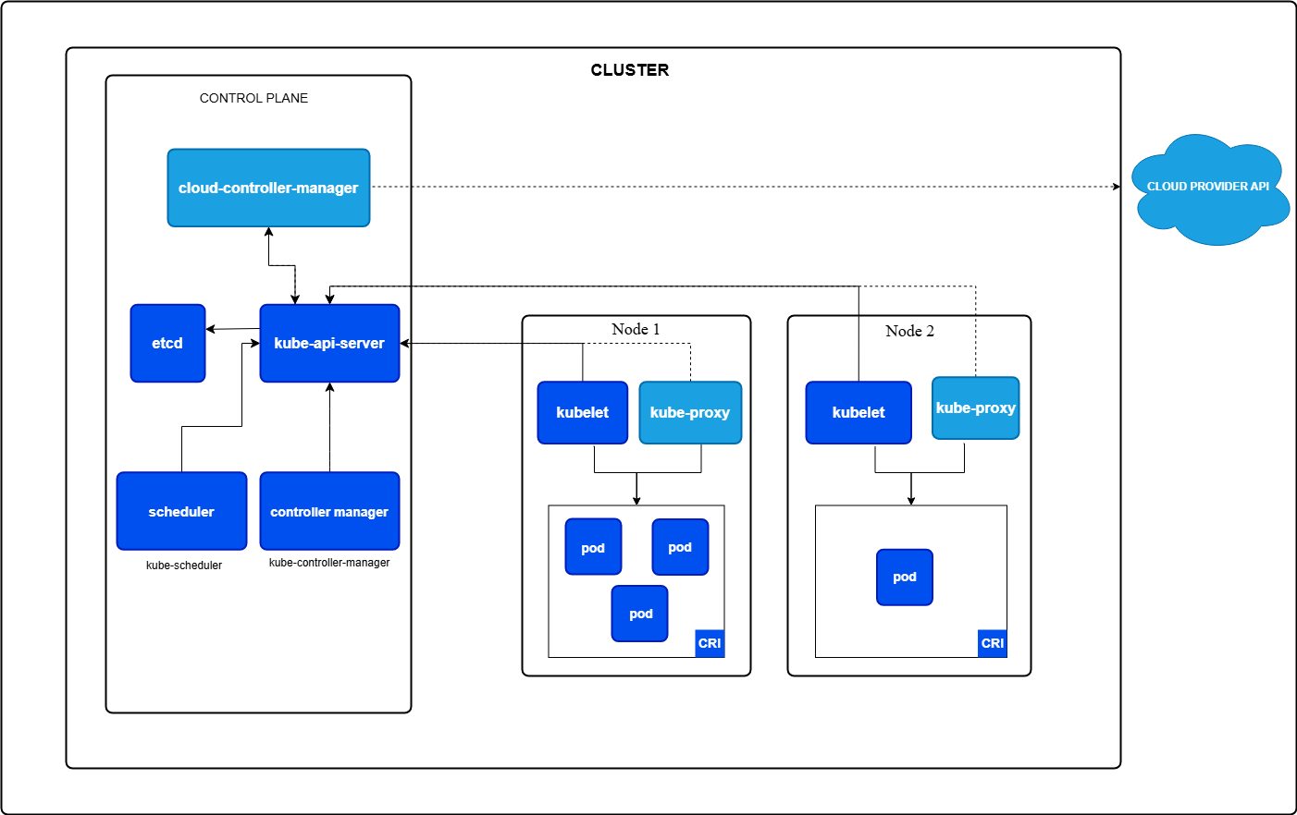

Clusters support scalability, reliability, and security with traits such as:
- Pods can move to different nodes as needed.
- The control plane runs on multiple nodes.
- Pods are isolated from each other, and the node processes run in a secure environment.

Control Plane Components
is a set of components that collectively manage the state of a Kubernetes cluster and make global decisions about the cluster (for example, scheduling), as well as detecting and responding to cluster events (for example, starting up a new pod when a Deployment's replicas field is unsatisfied).
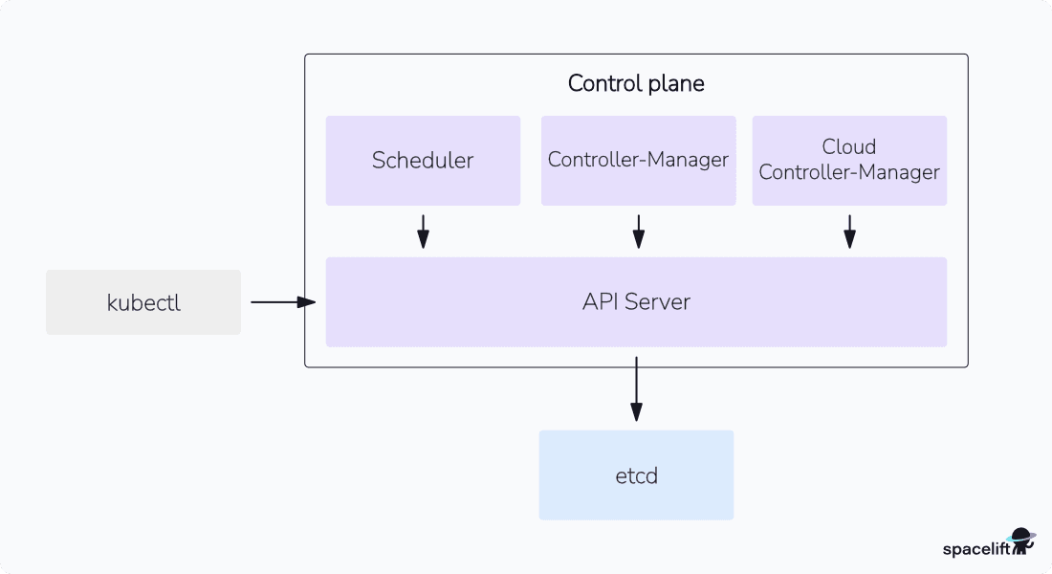
Control Plane Components
- Kube-API Server: It acts as the primary interface for cluster communication and responsible for handling external and internal requests—determining whether a request is valid and then processing it. The API can be accessed via the kubectl command-line interface or other tools like kubeadm, and via REST calls.
- etcd: It’s a key-value store is used as the cluster’s primary database. It stores configuration data, state information, and metadata about the cluster.
- Scheduler: The scheduler is responsible for assigning nodes to newly created pods based on resource availability and constraints. It also monitors the resource usage of individual nodes and makes decisions about where to deploy new pods.

- kube-controller-manager: The Kubernetes Controller Manager is a daemon that manages a cluster's state by running multiple controllers. It's a key component of the Kubernetes control plane.
How it works
  - The controller manager monitors the cluster's state using the Kubernetes API server
  - It compares the current state to the desired state, as defined in Kubernetes manifests
  - If there are any discrepancies, the controller manager takes corrective actions to reconcile the cluster's state
  - What it does Ensures that there are enough healthy pods, Manages the namespace lifecycle, Handles service accounts, and Manages configuration changes.
  - Examples of controllers replication controller, endpoints controller, namespace controller, and serviceaccounts controller.

Embedded Controllers:
Several controllers are bundled within the kube-controller-manager, each responsible for a specific aspect of cluster management:

- Replication Controller:
  - Ensures the desired number of Pod replicas are running for Deployments or ReplicaSets.
- Deployment:
  - Provides a strategy for performing rolling updates and managing deployments, ensuring a smooth transition and minimal downtime.
- Namespace Controller:
  - Creates and manages Kubernetes namespaces, providing a way to isolate resources.
- Service Account Controller:
- Creates and manages Service Accounts used for Pod authentication and authorization.
- Node Controller:
  - Tracks the health and availability of Nodes in the cluster.

- CronJob::
  - Creates Job objects on a repeating schedule, for example, running backups or report generation. .

- StatefulSet:
  - Manages stateful applications that require persistent storage and ordered deployments, ensuring Pod identities are maintained.
- DaemonSet:
  - Ensures that a pod is running on all (or some) nodes of the cluster, often used for tasks like logging or monitoring.

- cloud-controller-manager: The Cloud Controller Manager (CCM) in Kubernetes is a control plane component that manages the interaction between the Kubernetes cluster and the underlying cloud provider's infrastructure, allowing cloud providers to develop and release features independently from the core Kubernetes project.
- Purpose:
The CCM decouples cloud-specific functionality from the Kubernetes core, allowing cloud providers to release features at a different pace than the main Kubernetes project and promotes Kubernetes' flexibility across diverse cloud environments.
- Functionality:
  - Manages controllers whose function is specific to cloud provider functionality, such as node controllers, service controllers, and route controllers.
  - Updates Kubernetes nodes using cloud APIs and deletes Kubernetes nodes that were deleted on the cloud.
  - Creates and manages load balancers on the cloud for Kubernetes services of type LoadBalancer.
  - Configures network routes within the cloud provider's infrastructure.
  - Integrates with the cloud provider to handle Kubernetes resources like load balancers, storage, and networking.

- Example:
  - The AWS cloud provider has its own CCM that handles AWS-specific services like Elastic Load Balancers (ELB) and Elastic Block Store (EBS), and Google Cloud has one for managing resources like Google Cloud Load Balancers and Persistent Disks.
- Key Benefits:
  - Cloud Agnostic: Enables Kubernetes to work with various cloud providers (AWS, Google Cloud, Azure, etc.) without being tied to a single one.
  - Independent Updates: Cloud providers can release features independently from the main Kubernetes project.
  - Focus on Cloud-Specific Logic: Allows cloud providers to focus on their specific cloud infrastructure and resources.
- Contrast with kube-controller-manager:
The kube-controller-manager is responsible for running controllers that are built into the Kubernetes core, while the CCM manages cloud-specific controllers.

Kubernetes Core Components: Worker Nodes:
- Nodes: Nodes are physical or virtual machines that can run pods as part of a Kubernetes cluster. A cluster can scale up to 5000 nodes. To scale a cluster’s capacity, you can add more nodes.
- PODS:

- Kubelet is a key component of Kubernetes that runs on each node in a cluster. It manages containers by:
  - Receiving Podspecs, which are specifications for containers
  - Ensuring containers are running and healthy
  - Starting, stopping, and restarting containers
  - Reporting the node's status back to the control plane
  - Creating, destroying, or updating pods and their Docker containers
  - Kubelet's role: Kubelet's role is to ensure that containers are running and properly managed within the node. It also helps with container orchestration and communication between the Kubernetes control plane and individual nodes.
- Kube-proxy: It is a network proxy that manages traffic between nodes in a Kubernetes cluster. It's a key component of Kubernetes networking that runs on each node in the cluster. How kube-proxy works
  - Watches the Kubernetes control plane for changes to services and endpoints
  - Configures the node to capture traffic to the service's cluster IP and port
  - Redirects traffic to one of the service's endpoints
  - Uses iptables or IPVS to configure the Linux kernel's packet modification and forwarding rules.

K8S services:
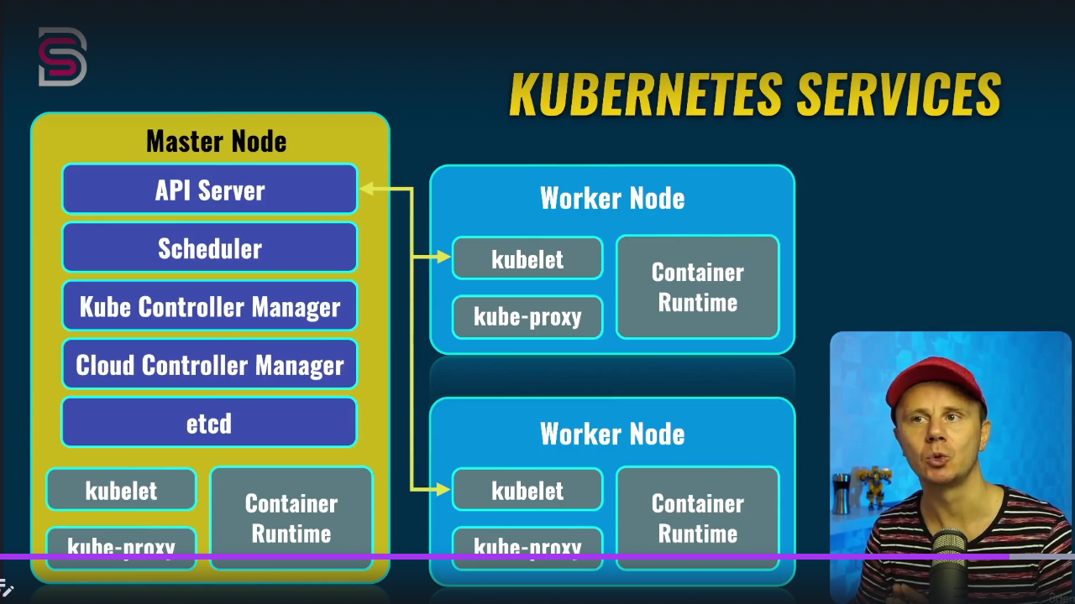
In Kubernetes, what is the difference between a service and a deployment?
In Kubernetes a deployment is a method of launching a pod with containerized applications and ensuring that the necessary number of replicas is always running on the cluster.

On the other hand, a service is responsible for exposing an interface to those pods, which enables network access from either within the cluster or between external processes and the service.
In Kubernetes, each pod is assigned its IP address but the pods are ephemeral that is they can be destroyed easily and when a new pod is created in place of them a new IP address is assigned to them. Here the role of services comes into the picture. A service is like a permanent IP address assigned to a pod. A service IP address is stable. So instead of sending a request to a pod, the client requests a service, and the service forwards that request to the desired pod. Services also help in load-balancing.
Why Services are needed in Kubernetes?
Services are necessary because of the distributed architecture of Kubernetes clusters. Apps are routinely deployed as Pods that could have thousands of replicas, spanning hundreds of physical compute Nodes. When a user interacts with your app, their request needs to be routed to any one of the available replicas, regardless of where it’s placed.
Services sit in front of your Pods to achieve this behavior. All network traffic flows into the Service before being redirected to one of the available Pods. Your other apps can then communicate with the service’s IP address or DNS name to reliably access the Pods you’ve exposed.
Kubernetes Service types
1. ClusterIP Services
ClusterIP Services assign an IP address that can be used to reach the Service from within your cluster. This type doesn’t expose the Service externally.
ClusterIP is the default service type used when you don’t specify an alternative option. It’s the most common kind of service you’ll use as it enables simple internal networking for your workloads.
2. NodePort Services
NodePort Services are exposed externally through a specified static port binding on each of your Nodes. Hence, you can access the Service by connecting to the port on any of your cluster’s Nodes. NodePort Services are also assigned a cluster IP address that can be used to reach them within the cluster, just like ClusterIP Services.
Use of NodePort Services is generally unadvisable. They have functional limitations and can lead to security issues:
- Anyone who can connect to the port on your Nodes can access the Service.
- Each port number can only be used by one NodePort Service at a time to prevent conflicts.
- Every Node in your cluster has to listen to the port by default, even if they’re not running a Pod that’s included in the Service.
- No automatic load-balancing: clients are served by the Node they connect to.
When a NodePort Service is used, it’s generally to facilitate the use of your own load-balancing solution that reroutes traffic from outside the cluster. NodePorts can also be convenient for temporary debugging, development, and troubleshooting scenarios where you need to quickly test different configurations.
3. LoadBalancer Services
LoadBalancer Services are exposed outside your cluster using an external load balancer resource. This requires a connection to a load balancer provider, typically achieved by integrating your cluster with your cloud environment. Creating a LoadBalancer service will then automatically provision a new load balancer infrastructure component in your cloud account. This functionality is automatically configured when you use a managed Kubernetes service such as Amazon EKS or Google GKE.
Once you’ve created a LoadBalancer service, you can point your public DNS records to the provisioned load balancer’s IP address. This will then direct traffic to your Kubernetes Service. Therefore, LoadBalancers are the Service type you should normally use when you need an app to be accessible outside Kubernetes.
4. ExternalName Services
ExternalName Services allow you to conveniently access external resources from within your Kubernetes cluster. Unlike the other Service types, they don’t proxy traffic to your Pods.
When you create an ExternalName Service, you have to set the spec.externalName manifest field to the external address you want to route to (such as example.com). Kubernetes then adds a CNAME DNS record to your cluster that resolves the Service’s internal address (such as my-external-service.app-namespace.svc.cluster.local) to the external address (example.com). This allows you to easily change the external address in the future, without having to reconfigure the workloads that refer to it.
5. Headless Services
Headless services are a special type of Service that don’t provide load balancing or a cluster IP address. They’re “headless” because Kubernetes doesn’t automatically proxy any traffic through them. This allows you to use DNS lookups to discover the individual IP addresses of any Pods selected by the Service.
A headless service is useful when you want to interface with other service discovery systems without kube-proxy interfering. You can create one by specifically setting a Service’s spec.clusterIP field to the None value.

Which Service type should I use?
The correct Kubernetes Service type for a particular workload primarily depends on whether you’ll need external access. If you will interact with a Service from outside Kubernetes, then LoadBalancers should be preferred. A NodePort Service can be useful instead if you can accept its tradeoffs, a load balancer integration is unavailable, or you plan to implement your own load balancing solution.
For workloads that will only be accessed within your cluster—typically including database connections, caches, and other internal system components—ClusterIPs should be used to prevent inadvertently exposing the Service. Developers and operators can still connect to these Services from their workstations to debug problems and manually interact with workloads using the port-forwarding features available in Kubectl.

kubectl:
kubectl is a command-line tool that lets you manage and communicate with Kubernetes clusters. It's the primary way most people interact with Kubernetes.
What you can do with kubectl
- Deploy applications
- Manage cluster resources
- View logs
- Query and manage cluster health
- Create resources
- Update and delete resources
- Debug Kubernetes objects
- Copy files and directories to and from containers
Creating a single Pod: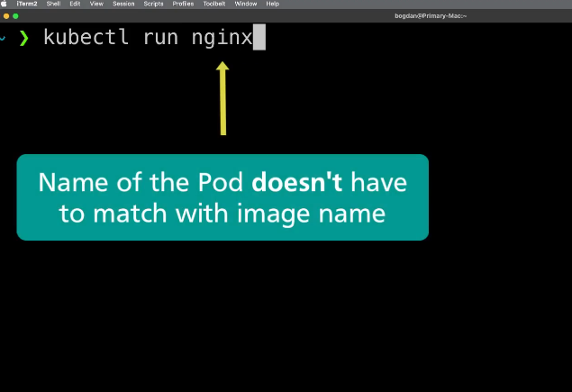
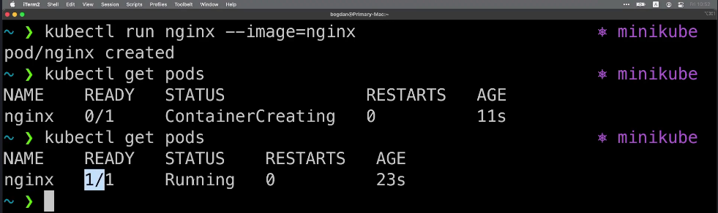

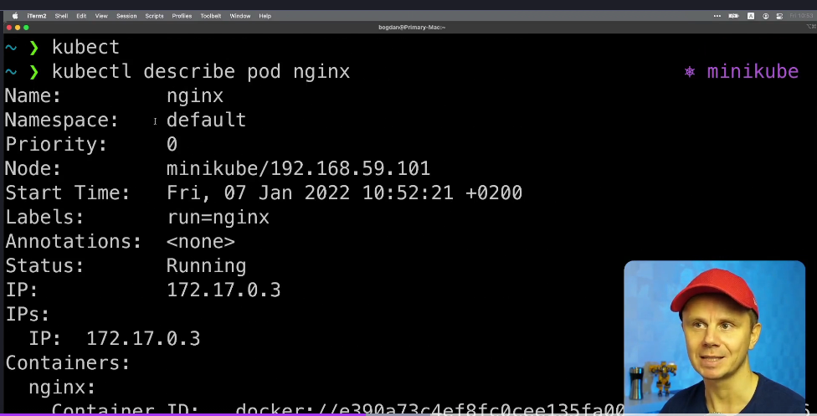
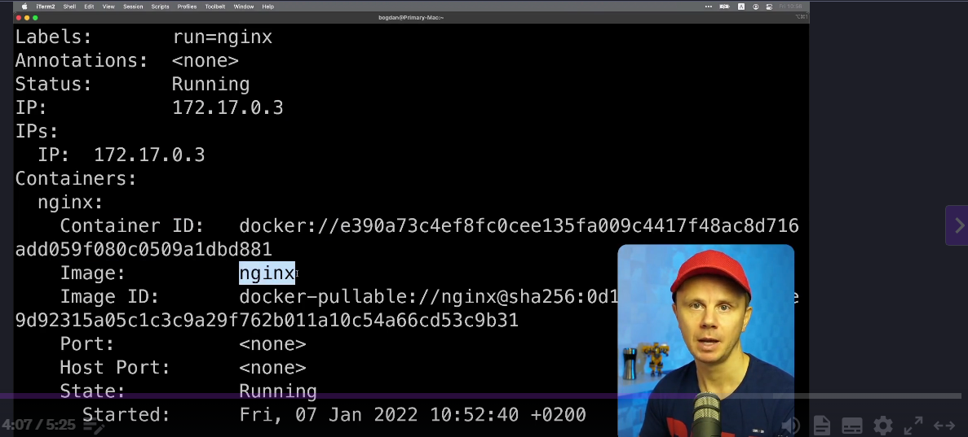

Creating and Exploring Deployment:
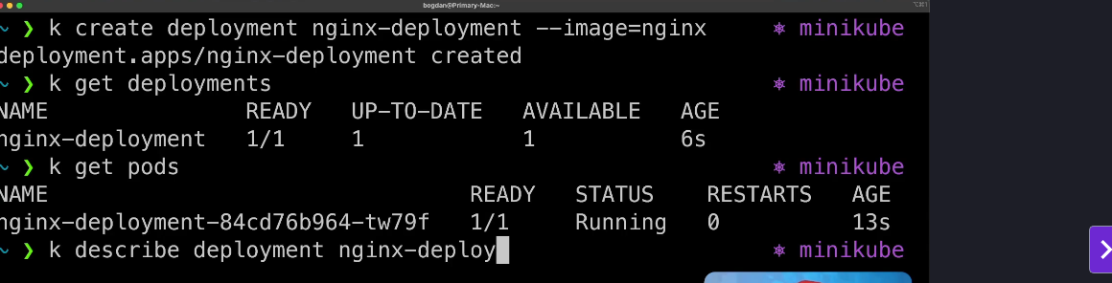
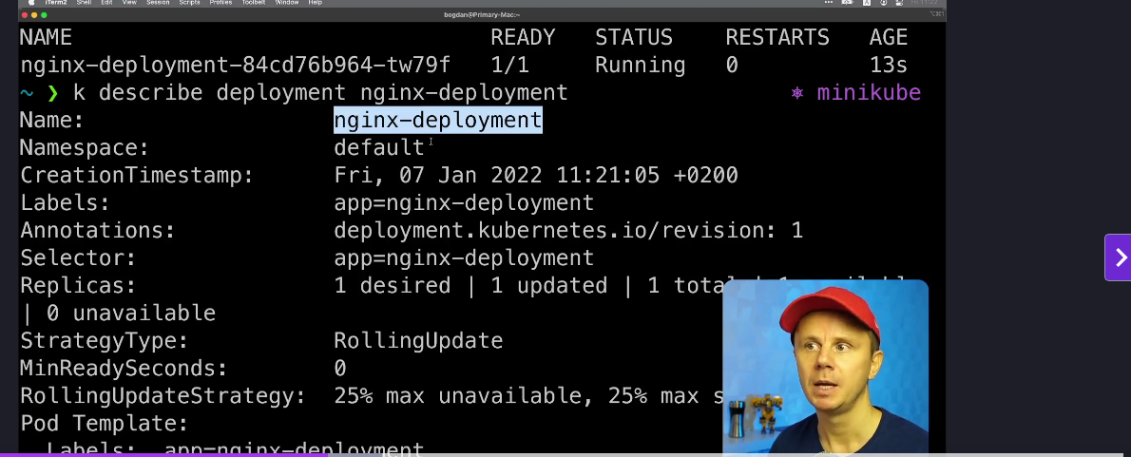

Scaling Deployment:
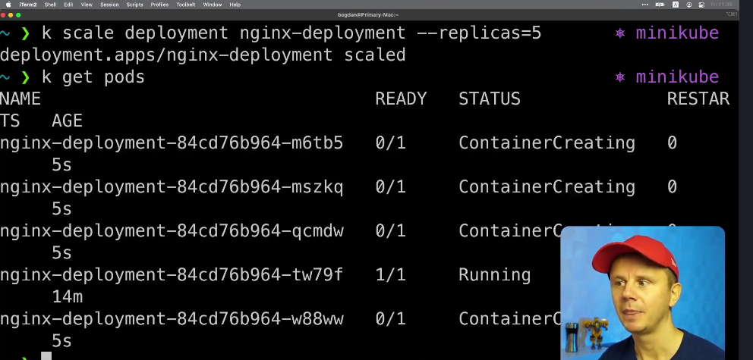

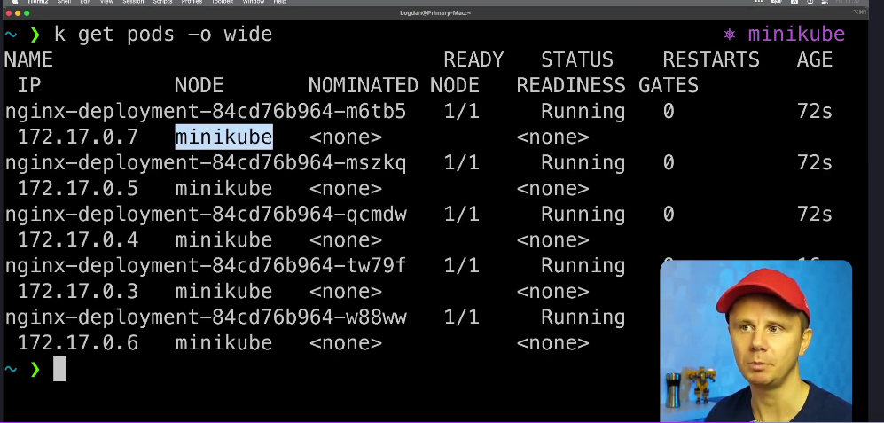

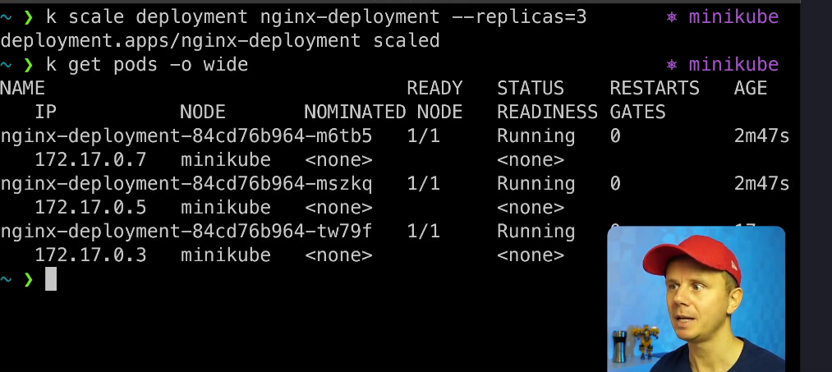

Creating and Exploring IP Address:
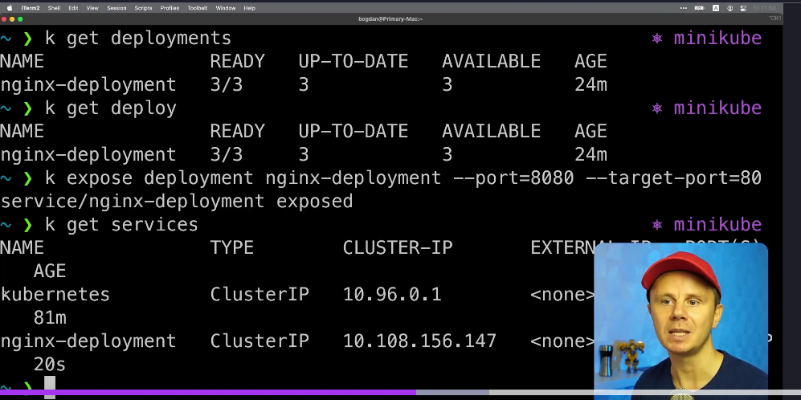

Connecting to Deployment using Cluster IP Address:
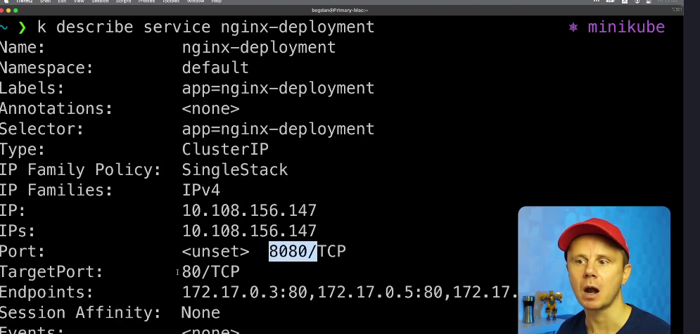

Pushing Docker image to Docker HUB:

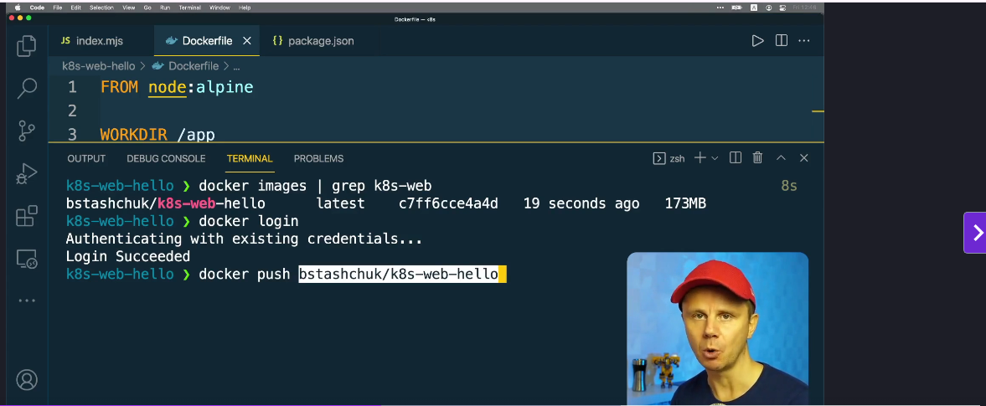

NodePort service:
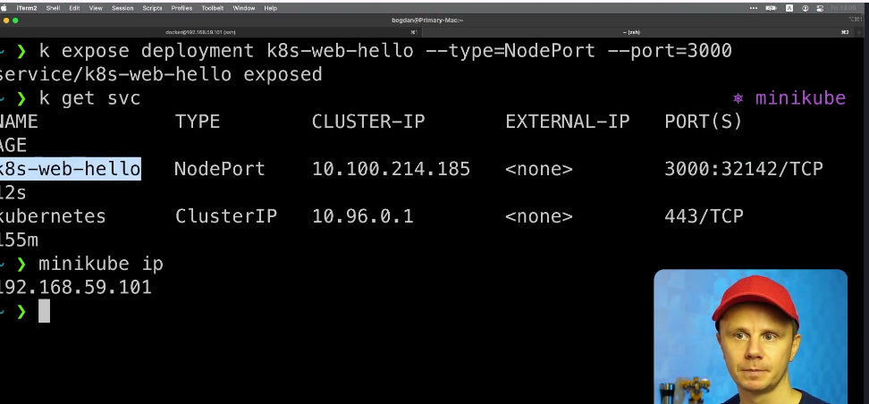

Load Balancer Service:
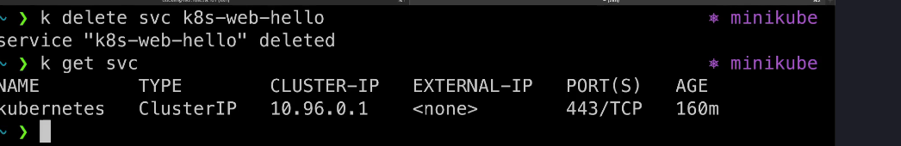

Rolling Update of the Deployment:
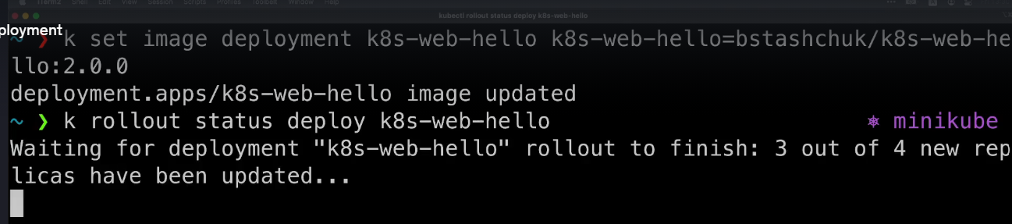

What Happens if one of the pod get deleted:
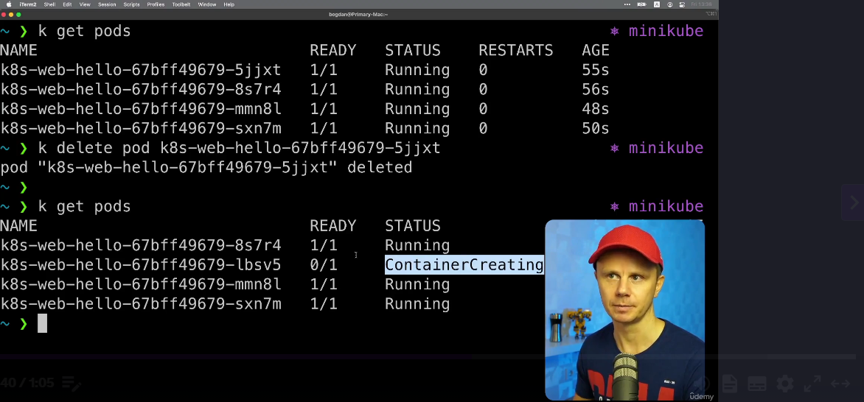

K8s YML file for Deployment:

NameSpace:
Kubernetes namespaces are a method by which a single cluster used by an organization can be divided and categorized into multiple sub-clusters and managed individually. Each of these clusters can function as individual modules where users across various modules can interact and share information as necessary.
While the clusters can function autonomously, they are still connected to other clusters and aren’t completely independent, and can even support one cluster nested within another. In general, there is a default namespace where all the resources exist. Unless otherwise specified, all the relevant commands will apply to this default namespace.
Why use Kubernetes namespaces?
Kubernetes namespaces have numerous applications, including:
- Allowing teams or projects to existing in their own virtual clusters without interfering with the work of others.
- Role-based access controls (RBAC) are being improved by restricting users and processes to specific namespaces.
- Using resource quotas, you can divide a cluster’s resources among multiple teams and users.
- Provides a simple method for separating containerized application development, testing, and deployment, allowing the entire lifecycle to take place on the same cluster.
Example of a basic YAML file for Kubernetes deployment
- The example below will create a Kubernetes Deployment named “example-deployment” with three replicas, each running a pod based on the specified container image and port configuration. The pods will be labeled with “app: example,” and they will be managed by the Deployment.

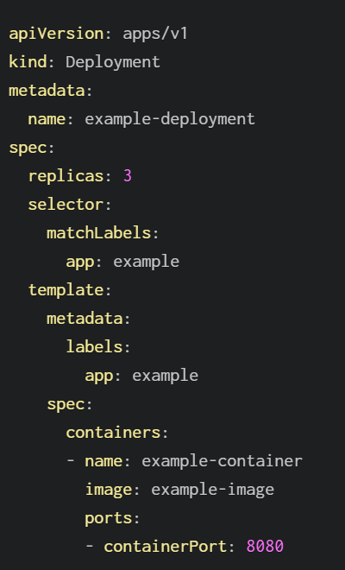
Let’s break each line down…
- apiVersion: Specifies the Kubernetes API version. In this case, it’s using the “apps/v1” API version, which is appropriate for Deployments.
- kind: Specifies the type of Kubernetes resource. Here, it’s “Deployment,” indicating that this configuration file is defining a Deployment.
- spec: This section defines the desired state of the Deployment.
- replicas: 3: Specifies that you want to run three replicas of your application.
- selector: Describes the selector to match pods managed by this Deployment.
- matchLabels: Specifies the labels that the Replica Set created by the Deployment should use to select the pods it manages. In this case, pods with the label app: example are selected.
- template: Defines the pod template used for creating new pods.
- metadata: Contains the labels to apply to the pods created from this template. In this case, the pods will have the label app: example.
- spec: Describes the specification of the pods.
- containers: This section specifies the containers to run in the pod.
- name: example-container: Assigns a name to the container.
- image: example-image: Specifies the Docker image to use for this container.
- ports: Defines the ports to open in the container.
- containerPort: 8080: Indicates that the container will listen on port 80.
https://codefresh.io/learn/kubernetes-deployment/kubernetes-deployment-yaml/
Service yaml
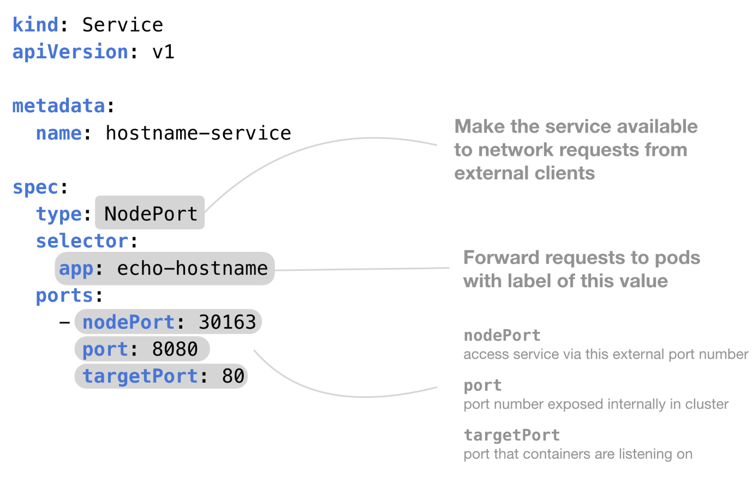

And here's some example YAML code that shows you how to use a NodePort service in Kubernetes.
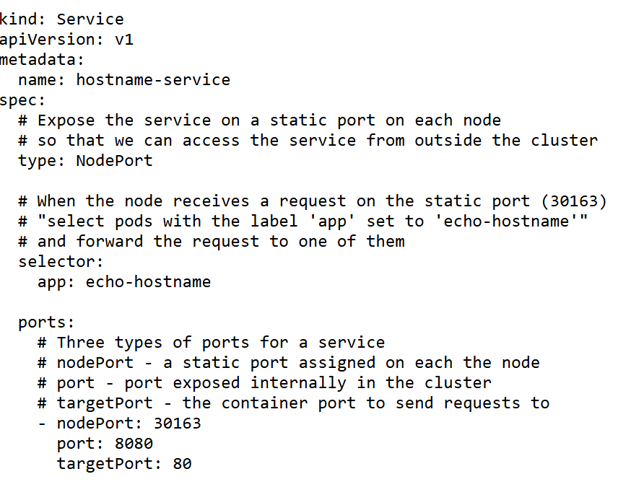
https://kubernetes.io/docs/concepts/storage/volumes/

